**REQUIREMENTS AND SPECIFICATIONS DOCUMENT**

This document contains a complete description of the requirements for our IoT platform software system, which is the primary product of the requirements definition phase. Thus, this document will provide high level descriptions of the tools and processes that will be used to achieve these requirements.

**1. introduction**

The purpose of this proposed project is to develop an IoT platform that will monitor the available parking spaces in a parking structure. In efforts to help reduce the amount of time taken to find available spaces, this system would be developed to help alleviate the amount of time it takes for people to find a space to park their vehicles by managing and displaying available spaces.

**2. System overview**

The overall system concept will be simple. Smart sensors that would detect vehicles will be able to communicate with the proposed IoT platform when spaces are occupied or unoccupied, and users would be able to view that information via a display or through their mobile devices. The IoT will have frequent recollection of data from the network of the smart parking sensors to allow for recent updates on their availability statuses. The platform would provide the information and display the output onto a monitor at the facility or to user mobile devices at the user’s request.

**System Diagram/ Expected Operating Environment**

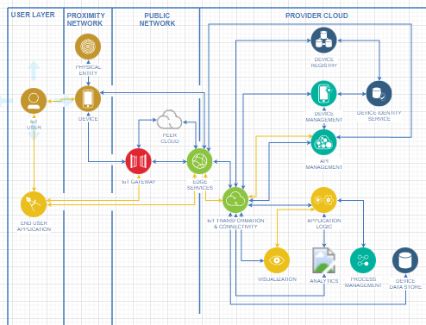

**3. Requirements**

1. Proximity device
   1. It should be small and not need a lot of electrical power.
   2. Must have wireless capabilities (Bluetooth or Wi-Fi)
   3. Able to send an on/off message
2. Wireless network
   1. Must be able to hold 100+ wireless connections
   2. Closed gateway
   3. Connect to cloud services
   4. Able to scale for signal strength
3. Message Broker
   1. Must be able to route signals/message
   2. Handles 25 messages per second
4. Cloud Provider
   1. Must support IoT processes
   2. Have 2GB+ of RAM
   3. Have 50GB+ Storage space
   4. Provides Ubuntu OS
5. Operating system
   1. Ubuntu OS
6. Web Services
   1. Use Linux OS (Ubuntu)
   2. Use Apache as webserver
   3. MySQL as DBMS
   4. PHP as programming language
7. Security
   1. Use SSH
   2. Use SSL
   3. Username Name required
   4. Password required

**4. Specification**

* Parking Spaces
  + Each number uniquely
  + Has a proximity device installed.
  + In reach of wireless signal
* Proximity Devices
  + Gather information on parking space occupation
  + Send signal when parking space occupied
  + Send signal when space unoccupied
* Wireless Network
  + Connects to all proximity devices
  + Carries messages from devices
* Ubuntu
  + Runs microservices
  + Messages from proximity devices routed to necessary destinations
* MySQL
  + Updates and verifies devices and locations
* Web Services
  + Updated status and displays parking availability based on message from Proximity devices and MySQL.